|  |
| --- |
| GOOGLE BCG MATRIX |
| Google  Cairo University  **TEAM 10** |

|  |  |  |  |
| --- | --- | --- | --- |
| **Name** | **BN** | **SEC** | **code** |
| **Abdelaziz Salah** | **1** | **2** | **9202810** |
| **Abdelrahman Nomaan** | **2** | **2** | **9202851** |
| **Abdelrahman Hamdy** | **36** | **1** | **9202833** |
| **Ahmed Alaa** | **7** | **1** | **9202141** |
| **Kirollos Samy** | **11** | **2** | **9203087** |
| **Khaled Hesham** | **22** | **1** | **9202513** |

Supervised by:

**DR: Shaimaa Tayseer**

**22/11/2022**

**Cash Cow**

Google has a variety of products that generate high revenue each year and they are termed cash cow products. It has also made a lot of other money-making projects, such as Android, the world's most used mobile operating system. Google has been making some of its most dramatic moves in the past few years. AdSense generates about $1.3 billion a year in revenue for Google. And as we recently reported, Google search generates more than $20 billion annually, which accounts for 90% of Google's operating profit.

Google has released its annual earnings report for the last four years. The search engine giant has revealed a growth rate of revenue in the previous four years and is growing at an impressive rate of 25%. According to Google, it was a record year for the company, with $90 billion in revenue. This is a massive jump from the $79.3 billion recorded in the previous financial year.

Google and Microsoft (MS) are top players in the field of mobile operating systems. Chrome OS is also a cash cow product Android is developed by Google, which allows users to access the internet, send messages, and make calls through an Android-based mobile. In 2020-2022, Google made Android its mainstay and the topmost-selling operating system. It has become the world's most significant and fastest-growing mobile platform, with an estimated 1 billion active users.

**Question Marks**

The question mark Products category covers those products whose growth is slow. It is not necessarily in the problem category. Google Drive and Docs are an example of this. The growing demand for data protection and storage increased the cloud storage market and faced strong competition from Microsoft Office, which has a larger share of the office productivity market.

Google Docs isn't necessarily a wrong product, but it isn't likely to grow fast. The reasons for the lack of demand are many. Some products may fail to become popular because of poor quality and overpricing. Others may not succeed because people are not interested in them. Many factors can affect a product's success. Google is growing slowly but steadily in these products so that they can be classified as stable but not highly successful products.

**Dogs**

For Google, it was an actual dog product because they invested too much into something that did not take off. An example would be their Video Player, a project launched in late 2005, and then they spent over $3 million acquiring YouTube as well. Google eventually acquired Youtube and put it under the 'Google' label. That's where you will find every video on Youtube. Hence Google video player failed to get income.

Google Class might be another example of a product that was supposed to be a success, yet somehow didn't work out. It was a concept that many tech enthusiasts loved, but the public never warmed up to. There were many issues with the product, which never managed to impact the public.

Google Plus was another such failure, which was supposed to be one of the big players in the social network field.

**Stars**

Google Assistant, YouTube, and Google Maps have been driving the growth of mobile internet. Google is the largest search engine, and Google Maps is the number one navigation system. All three applications can be used to find out things, including getting directions, finding nearby businesses, and learning more about places, like where famous people live. These applications provide content that people can use daily, which is why they make Google more money.

YouTube, Google Maps, and Google's Assistant will generate maximum revenue from 2020-2022, according to a new forecast from Gartner. The research firm expects video

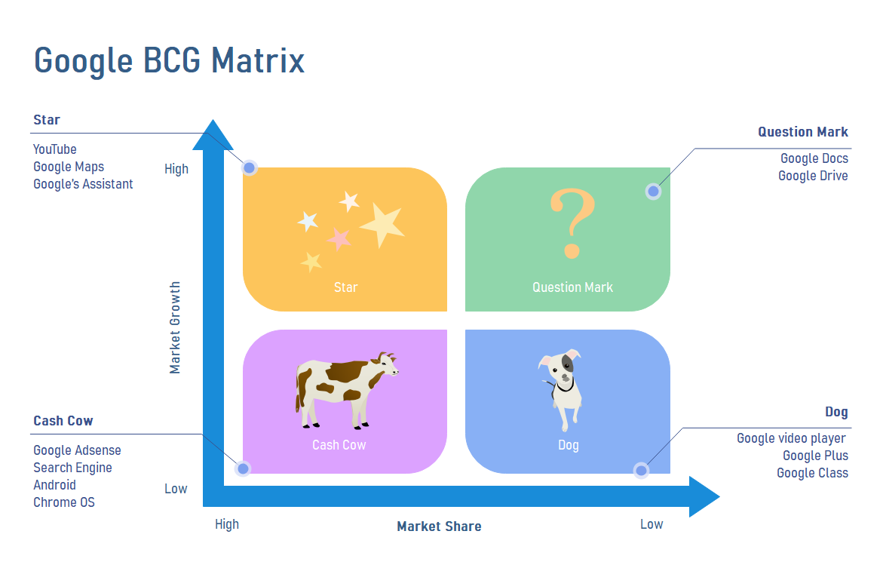advertising to grow at an annualized rate of 30 percent, with social media platforms accounting for 80 percent of the $50 billion industry.